# Crypto Market Algorithms Report

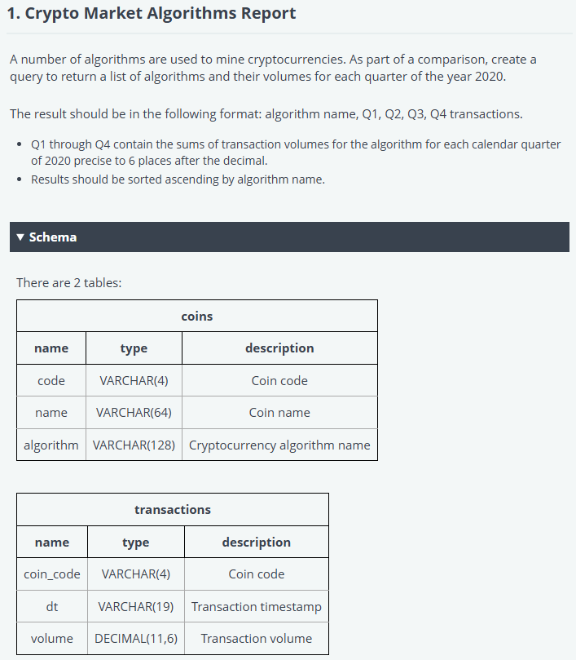

/*

Enter your query below.

Please append a semicolon ";" at the end of the query

*/

SELECT

    c.algorithm,

    -- Q1: January to March

    COALESCE(SUM(CASE WHEN EXTRACT(MONTH FROM t.dt) BETWEEN 1 AND 3 THEN t.volume ELSE 0 END), 0) AS transactions_Q1,

    -- Q2: April to June

    COALESCE(SUM(CASE WHEN EXTRACT(MONTH FROM t.dt) BETWEEN 4 AND 6 THEN t.volume ELSE 0 END), 0) AS transactions_Q2,

    -- Q3: July to September

    COALESCE(SUM(CASE WHEN EXTRACT(MONTH FROM t.dt) BETWEEN 7 AND 9 THEN t.volume ELSE 0 END), 0) AS transactions_Q3,

    -- Q4: October to December

    COALESCE(SUM(CASE WHEN EXTRACT(MONTH FROM t.dt) BETWEEN 10 AND 12 THEN t.volume ELSE 0 END), 0) AS transactions_Q4

FROM

    coins c

JOIN

    transactions t ON c.code = t.coin_code

WHERE

    EXTRACT(YEAR FROM t.dt) = 2020

GROUP BY

    c.algorithm

ORDER BY

    c.algorithm ASC;

# Crypto Market Transactions Monitoring

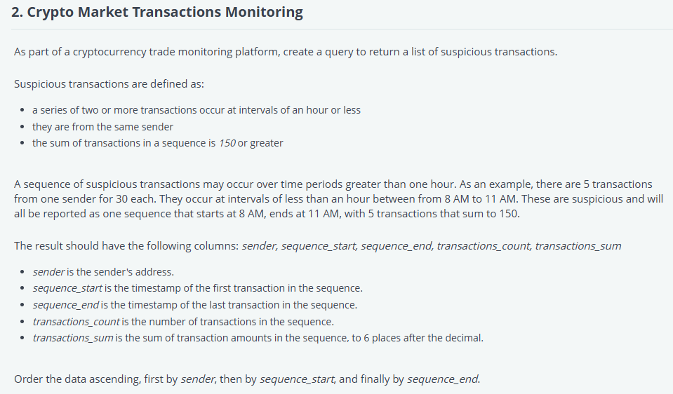

WITH difference AS (

SELECT *

, DATEDIFF(MINUTE, LAG(dt) OVER (ORDER BY sender, dt), dt) AS difF_minute

, ROW_NUMBER() OVER (ORDER BY sender, dt) AS rownumber

FROM [dbo].[Crypto]

),

rn AS (

SELECT rownumber

FROM difference

WHERE rownumber IN (

SELECT rownumber

FROM [dbo].[Crypto]

WHERE ABS(diff_minute) < 60

)

),

sequences_ as (

SELECT *

FROM difference

WHERE rownumber IN(

SELECT rownumber

FROM rn

UNION

SELECT rownumber - 1 as rownumber

FROM rn

)

)

SELECT sender

, MIN(dt) AS Sequence_start

, MAX(dt) AS Sequence_end

, COUNT(rownumber) AS transactions_count

, SUM(amount) AS transactions_sum

FROM sequences_

GROUP BY sender

HAVING SUM(amount) >= 150

ORDER BY sender, MIN(dt), MAX(dt)